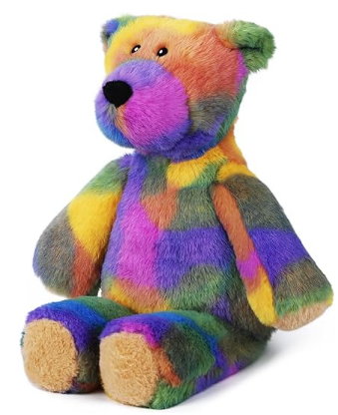
Guess the name of the bear.
If you guess the name of the bear, you win it!!!!
Please note if multiple people pick the correct name, then it will be the person who emails bspencer@newlandhouse.net you will get the bear.
There will be house points and sweets available for those who send in an entry.

Pick from below.

Archie | Frosty
Bertie | Grace
Blitzen | Gasby
Comet | Gerald
Cupid | Harry
Claire | Henry
David | Harold
Donner | Hugo
Eddy | Indigo
Edward | Izzy
Finn | Jermy
Freddie | Jerry
Frank | Jacob
John | Tom
Kattie | Tim
Luca | Umar
Matt | Upton
Nigel | Victor
Oggy | Valentine
Penelopy | Winton
Prancer | William
Qubert | Xavier
Rudulph | Zach
Rufus | Saint
Robert | Sam
Santa | Tuker

Good luck!!

