**Revision List for History Summer Exam May 2025**

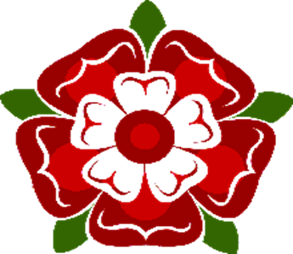

**Section One**

Ten short questions on Henry 8th – his wives and his children.

Make sure you know all of Henry’s wives’ names and children.

**Section Two**

There will then be 7 topics-You must write 2 mini-essays. These should be around 1 paragraph but can be as long as you like, and please try to put in all the information you know about that topic. Show off!

The 7 topics will be-

1.Henry Tudor the7th-how he got to power. The Battle of Bosworth Field. Was he a good ruler?

2. Mary Tudor-Turn or Burn!

3.The reign of Edward the 6th -Protestantism. Lady Jane Grey.

4. Life at Sea was horrible. How?

5.The life and voyages of Francis Drake.

6.William Shakespeare and the Tudor theatre- bear baiting, when plays occurred and groundlings etc-Plays by Shakespeare.